Cairo University Faculty of Computers and Information



**Software Engineering II**

**Software design specification document**

**2019**

**Project Team**

|  |  |  |  |
| --- | --- | --- | --- |
| **ID** | **Name** | **Email** | **Mobile** |
| 20170043 | Esraa Taha Ali | esraaselim39@gmail.com | 01102790226 |
| 20170044 | Esraa Mohamed Abd Elrahman | esraamohamed.egy@gmail.com | 01060081977 |
| 20170054 | Afnan Samir Mohamed | afnanetman@gmail.com | 01063750746 |
| 20170202 | Lubna Hassan Atia | Lubnahassan35@gmail.com | 01100095063 |

**Mohamed Hadad**

Title page has no header or footer.

Docs must be supplied as pdf –files re-named as requested

Contents

Instructions [To be removed] 2

Class diagram design 2

Sequence diagram design 3

Github repository link 5

# Class diagram design

* **You should provide clean version for your class diagram design.**
* **Class diagram is a static diagram and should not represent any dynamic flow of events.**
* **Put Relationships between classes and the types of the relationships.**
* **Put multiplicity.**
* **Put relationship name (e.g. faculty "offer" course).**
* **Put attributes in the classes.**
* **Put functions & Put parameters.**
* **Put data types of each attributes and the parameters.**
* **Highly perfered: Each class has a corresponding interface**
  + **Let all objects parameters and returns be of interface type.**
* **See Shopping Cart Case Study**

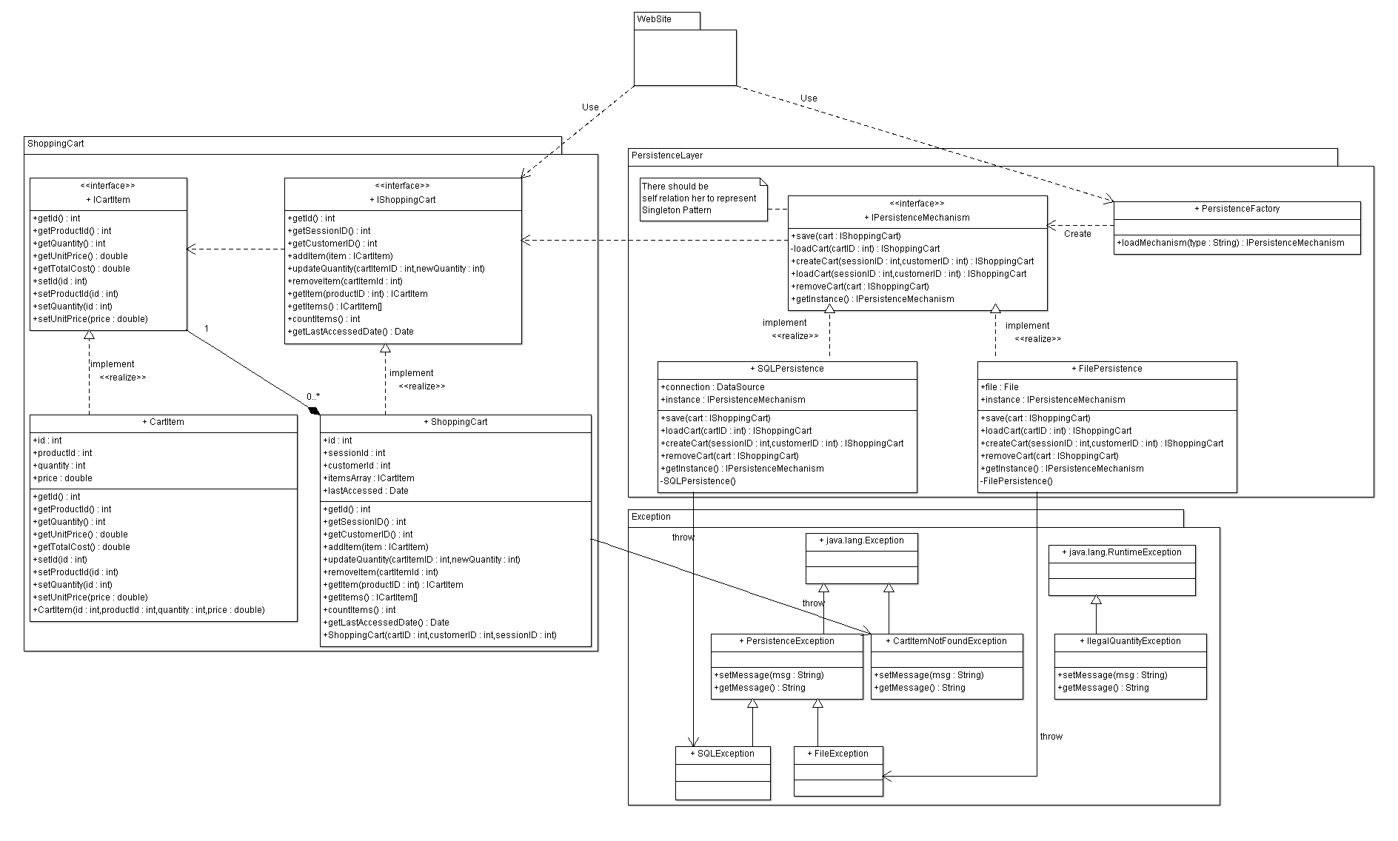

# Sequence diagram design

* **List Sequence diagrams for the most important user story (according to your opinion).**
* **Make sure that each object in the sequence diagram has a corresponding class in the class description table above. If not, it will be REJECTED.**
* **Put actual function calls with proper parameters and return types corresponding to class diagrams.**
* **Following are couple of examples for small / meduim examples. We expect such diagrams, however there is a missing thing in them. Most of calls don’t have parameters. Please always specify the parameters in the call, matching the class diagram.**

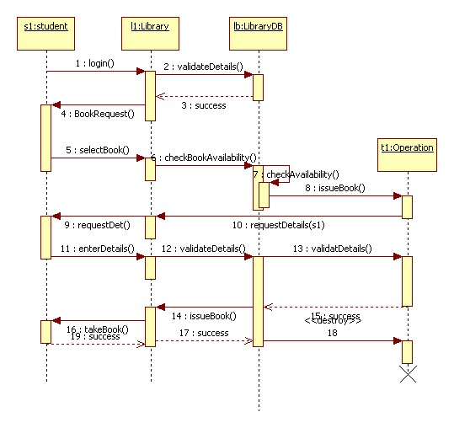

* 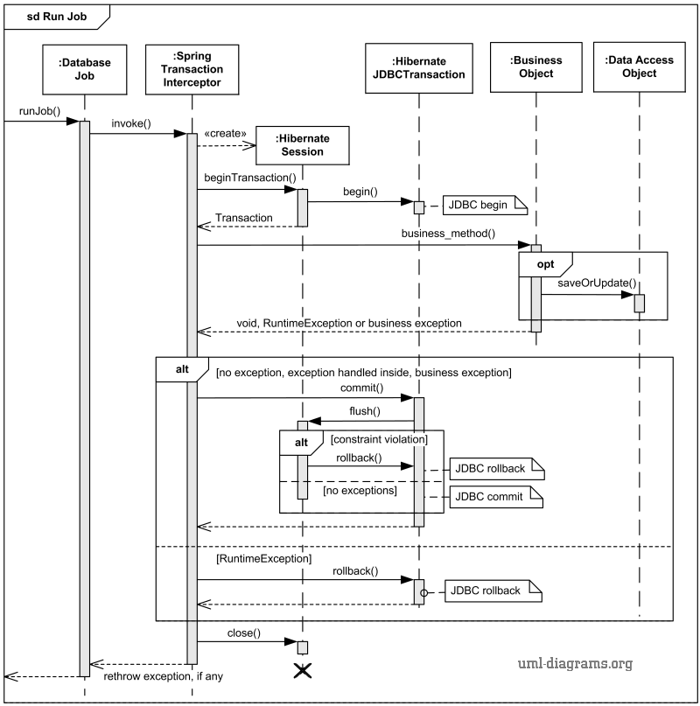

# Github repository link

* **URL for your repository, should contains implemented services**,